**Java & Web Development Project**

# Conception phase:

**Project objective:**

The long-term goal of the application is to provide Luxembourg based healthcare professionals and their patients an app that unifies the functionalities of the multitude of applications that are currently used to run a clinic. For this project, however, the aim will be to create an application that allows patients and healthcare professionals to book and manage appointments, upload prescriptions as PDFs and

**What requirements must the application fulfill?**

The application must be accessible via the internet for both professional accounts and patient accounts. The application will also need to be dynamic and reactive, as appointment availability will need to be updated dynamically and the application will need to fit the screen of different devices.

Web application Structure: The application is likely to be a Single-Page Application using a microservice architecture.

**Components, responsibilities, and interactions:**

* 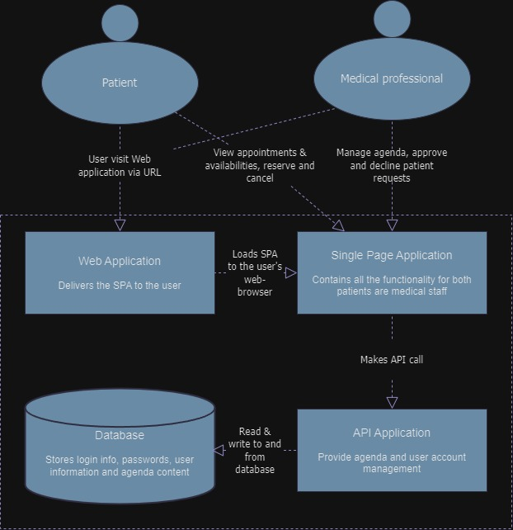API gateway: Manage microservice calls sent by the SPA
* Web application: calls the SPA to the user’s browser and displays it based on the HTML/CSS
* SPA: Provides all the functionality to the web application accessed by the users.

**Technologies:**

The LAMP stack will be used along with docker and GitHub. The LAMP stack has been selected as it is a commonly used stack that has been around for well over a decade. Many resources can be found online for this stack and I also personally have access to developers who are happy to provide feedback on my work.